I couldn’t retrieve the exact contents of the LLD item from your workspace, so I’ve prepared a copy-paste-ready LLD draft aligned to the accessible project document structure and module requirements I found for Data Uploads. If you’re targeting a different module, reply with just the module name (for example: I-Search, Reporting Portal, Training, RCM), and I’ll remap this 1:1 to that module’s FRS/SRS/HLD. I based the draft below on Project Insight 2.0_FRS_DataUploads_v1.0_v1.0.docx, Project Insight 2.0_SRS_DataUploads_v1.2.docx, CBDT_Insight_2_0_HLD_V_1_1_v1.0.docx, CBDT_Insight.0_Data_HLD_V_1.1_v1.0.docx, and CBDT_Insights_2_0_Solution_Architecture_V_1.1_v1.0.docx.

Source basis I used
The accessible Data Uploads documents define the module scope as intake of structured, semi-structured, and unstructured information; support for bulk upload and one-by-one portal upload; metadata capture; attachment handling; duplicate checks; approval workflow; additional-information loop; audit trail; OCR/summarization; and linkage to PAN/TAN/ITDREIN and downstream modules.
The accessible architecture documents state that the broader platform is microservices-based, API-first, uses REST over HTTPS for synchronous flows, supports versioned contracts, and separates channel/BFF/domain/data concerns.
The Data Uploads SRS further states that the software interface is Java-based microservices, Angular UI, REST/Webhook integrations, token/IAM/RBAC integration, and that data is loaded into PostgreSQL and subsequently synced downstream.

Proposed LLD Draft — Data Uploads Module
Important: The endpoint names, payload shapes, tables, and internal component names below are a proposed LLD design created to satisfy the cited requirements. These exact API paths and field names are not explicitly defined in the source docs.

1. Proposed LLD TOC
This TOC is aligned to the accessible project document patterns (intro → scope → interfaces → functions/use cases → NFR → constraints → traceability/supporting information).
1 1. About This Document
2 1.1 Purpose
3 1.2 Scope
4 1.3 References
5 1.4 Design Assumptions
6
7 2. Design Overview
8 2.1 Context and Scope
9 2.2 Design Goals
10 2.3 Architectural Alignment
11 2.4 Personas and Access Model
12
13 3. Component-Level Design
14 3.1 Experience Layer
15 3.2 BFF / API Gateway Layer
16 3.3 Domain Microservices
17 3.4 Workflow / Approval Engine
18 3.5 Document & Attachment Services
19 3.6 Validation & DQ Services
20 3.7 Audit / Observability Services
21 3.8 Integration Services
22
23 4. Data Design
24 4.1 Canonical Entities
25 4.2 PostgreSQL Logical Schema
26 4.3 Status Model
27 4.4 Audit Model
28 4.5 Idempotency / Duplicate Model
29
30 5. API Design
31 5.1 Authentication and Authorization
32 5.2 Bulk Upload APIs
33 5.3 One-by-One Upload APIs
34 5.4 Approval APIs
35 5.5 Additional Information APIs
36 5.6 Tracking / Status APIs
37 5.7 Error Model
38
39 6. Detailed Use Case Realization
40 6.1 UC-DU-02 Packet Preparation
41 6.2 UC-DU-03 Secure Package Creation
42 6.3 UC-DU-04 Bulk Portal Upload
43 6.4 UC-DU-05 One-by-One Upload
44 6.5 UC-DU-06 Approval Flow
45 6.6 UC-DU-07 Additional Information
46
47 7. Sequence Diagrams
48 7.1 Bulk Preparation and XML Generation
49 7.2 Secure Package Creation
50 7.3 Bulk Upload and Acknowledgement
51 7.4 One-by-One Submission
52 7.5 Two-Level Approval Cycle
53
54 8. NFR, Security and Controls
55 8.1 Security
56 8.2 Reliability and Retry
57 8.3 Performance
58 8.4 Auditability and Traceability
59 8.5 Data Quality and Duplicate Detection
60
61 9. Deployment and Configuration
62 9.1 Runtime Components
63 9.2 Configurable Masters
64 9.3 Promotion and Rollback
65 9.4 Logging and Monitoring
66
67 10. Traceability Matrix

2. Design Overview
The Data Uploads module is intended to act as the system’s formal intake layer, supporting bulk utility-based preparation and portal upload, one-by-one portal capture, workflow-based approval, request/response for additional information, and downstream linkage to profile and other modules.
The SRS explicitly maps the key use cases as: download utility, prepare packet, create secure package, bulk upload, one-by-one upload, approval flow, additional information handling, and inter-module integration.
The broader HLD/Solution Architecture expects modular design, standardized interfaces, API-first interaction, traceability across the lifecycle, and re-use of shared services such as identity, workflow, notifications, and audit.

2.1 Proposed component decomposition
Proposed components (LLD design):
- upload-bff — channel-facing BFF for portal UI
- bulk-upload-service — bulk package intake, acknowledgement, status tracking
- record-upload-service — one-by-one create/edit/draft/submit
- approval-service — two-level review/approve/reject/return/additional-info decisioning
- validation-service — field/schema/attachment/business-rule validation and duplicate checks
- document-service — attachment staging, metadata, linkage, retrieval
- audit-service — immutable business audit trail
- integration-service — downstream linkage to Profile View / processing / analytics
- reference-master-service — metadata masters, lookup values, sensitivity/type masters
The decomposition is justified because the sources require RBAC, workflow, attachments, audit trail, duplicate rejection, downstream linkage, and interoperable APIs / microservices.

3. Proposed Core Data Model
The source documents require: metadata capture, supporting documents, packet/record statuses, audit trails, duplicate detection, versioning of original/corrected/updated information, and approval history.

3.1 Proposed logical entities
- upload_batch — bulk upload submission unit
- upload_packet — packet header created in utility / imported to portal
- upload_record — atomic one-by-one or decomposed packet row
- attachment — uploaded supporting document metadata + blob reference
- approval_instance — workflow instance for review path
- approval_action — stage-level action history
- additional_info_request — clarification request
- additional_info_response — uploader response
- validation_result — rule failures / warnings / duplicate results
- audit_event — immutable action log
- profile_linkage — PAN/TAN/ITDREIN mapping status

3.2 Proposed status model
Packet / batch statuses (proposed):
- DRAFT
- VALIDATED
- PACKAGE_CREATED
- SUBMITTED
- FAILED
- REJECTED
- UNDER_REVIEW
- PENDING_APPROVAL_L1
- PENDING_APPROVAL_L2
- APPROVED
- RETURNED_FOR_CORRECTION
- PENDING_ADDITIONAL_INFO
These are aligned to statuses explicitly visible in the SRS such as Draft Saved, Submitted, Under Processing, Failed, Rejected, and approval outcomes such as Approved, Rejected, Returned for Correction, Pending Additional Information.

4. Proposed Sequence Diagrams (Mermaid)

4.1 UC-DU-02 — Packet preparation and XML generation
The SRS defines packet preparation as: capture packet metadata → capture/import rows → attach documents → validate → correct → generate XML → log audit.
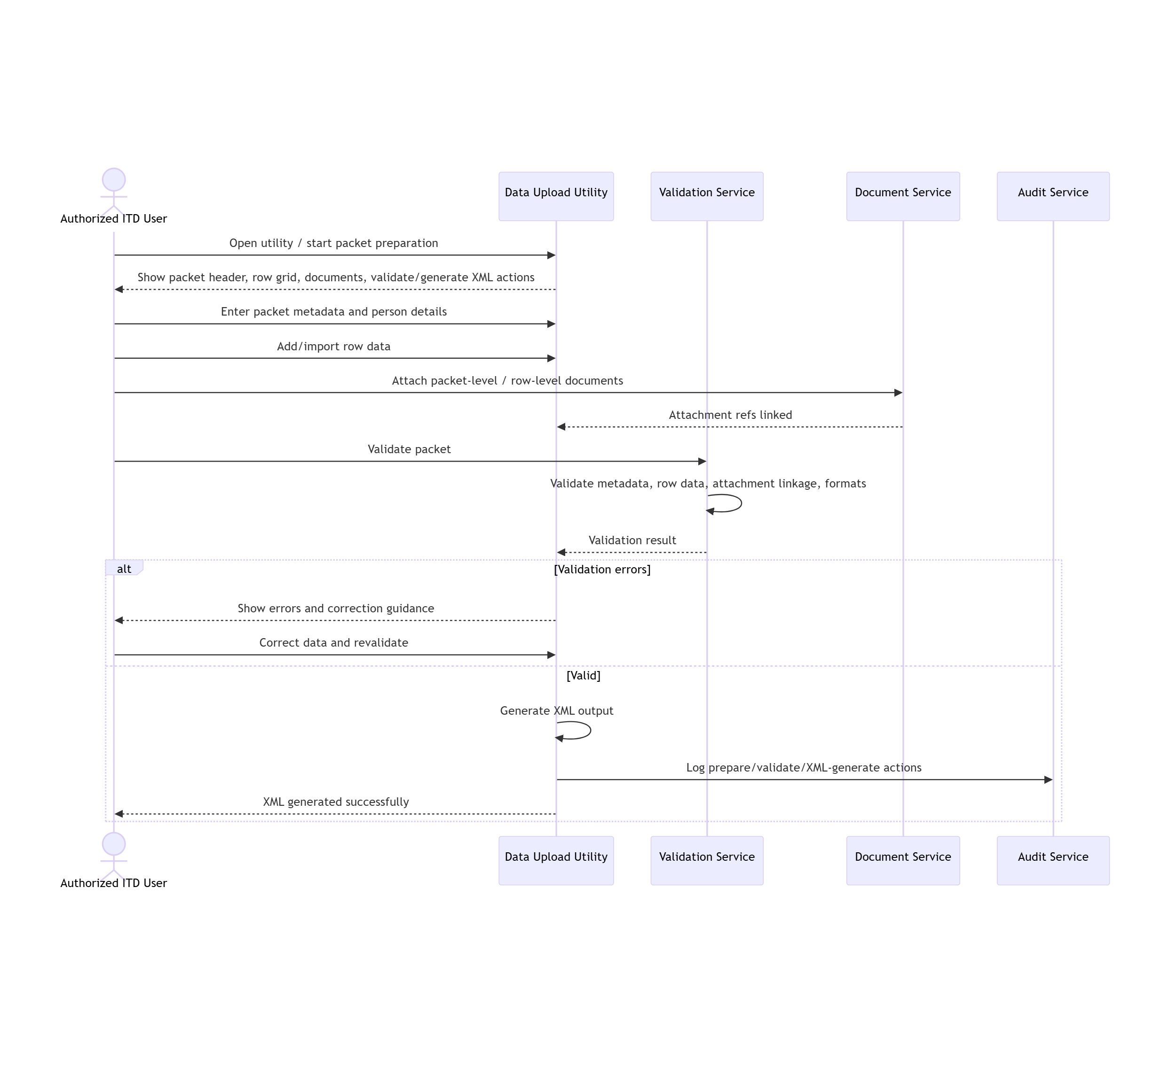

4.2 UC-DU-03 + UC-DU-04 — Secure package creation and bulk portal submission
The SRS defines secure package creation as selecting the validated XML, resolving linked documents, validating package-readiness, and generating the secure package; bulk portal upload then validates the package, stores it, generates acknowledgement/reference, and routes it to workflow.
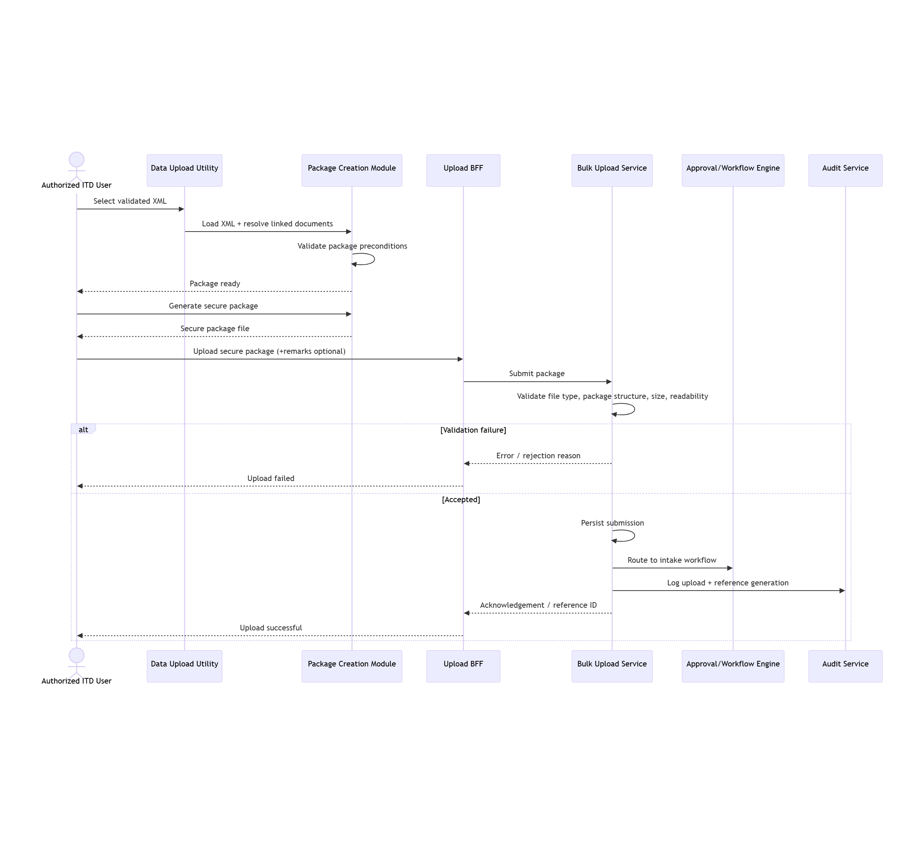

4.3 UC-DU-05 — One-by-one portal upload
The SRS defines a screen-based flow: capture metadata/details/dynamic fields/attachments → save draft or submit → full validation → status tracking.
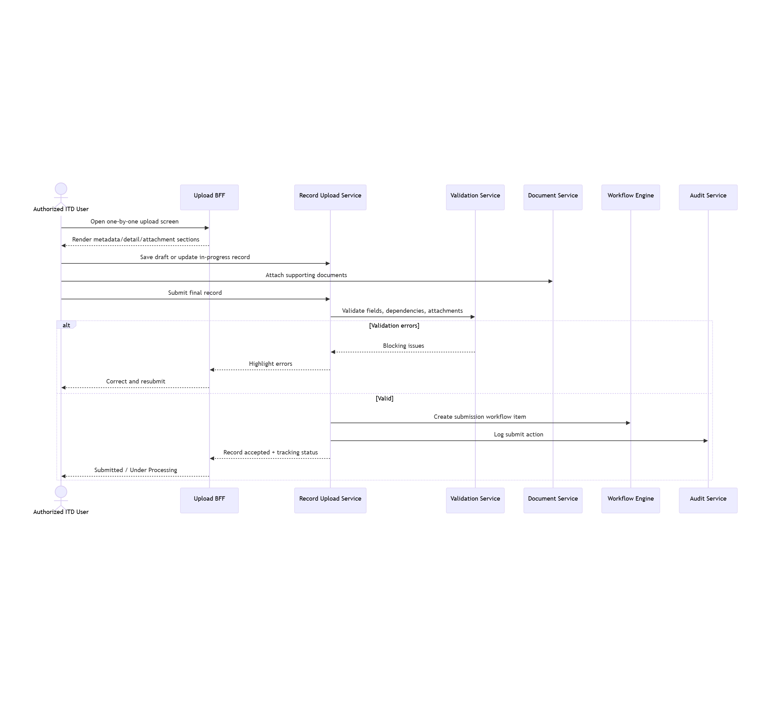

4.4 UC-DU-06 — Two-level approval
The SRS explicitly supports Approve/Forward, Final Approve, Reject, Return for Correction, and Request Additional Information, including a two-level approval path where configured.
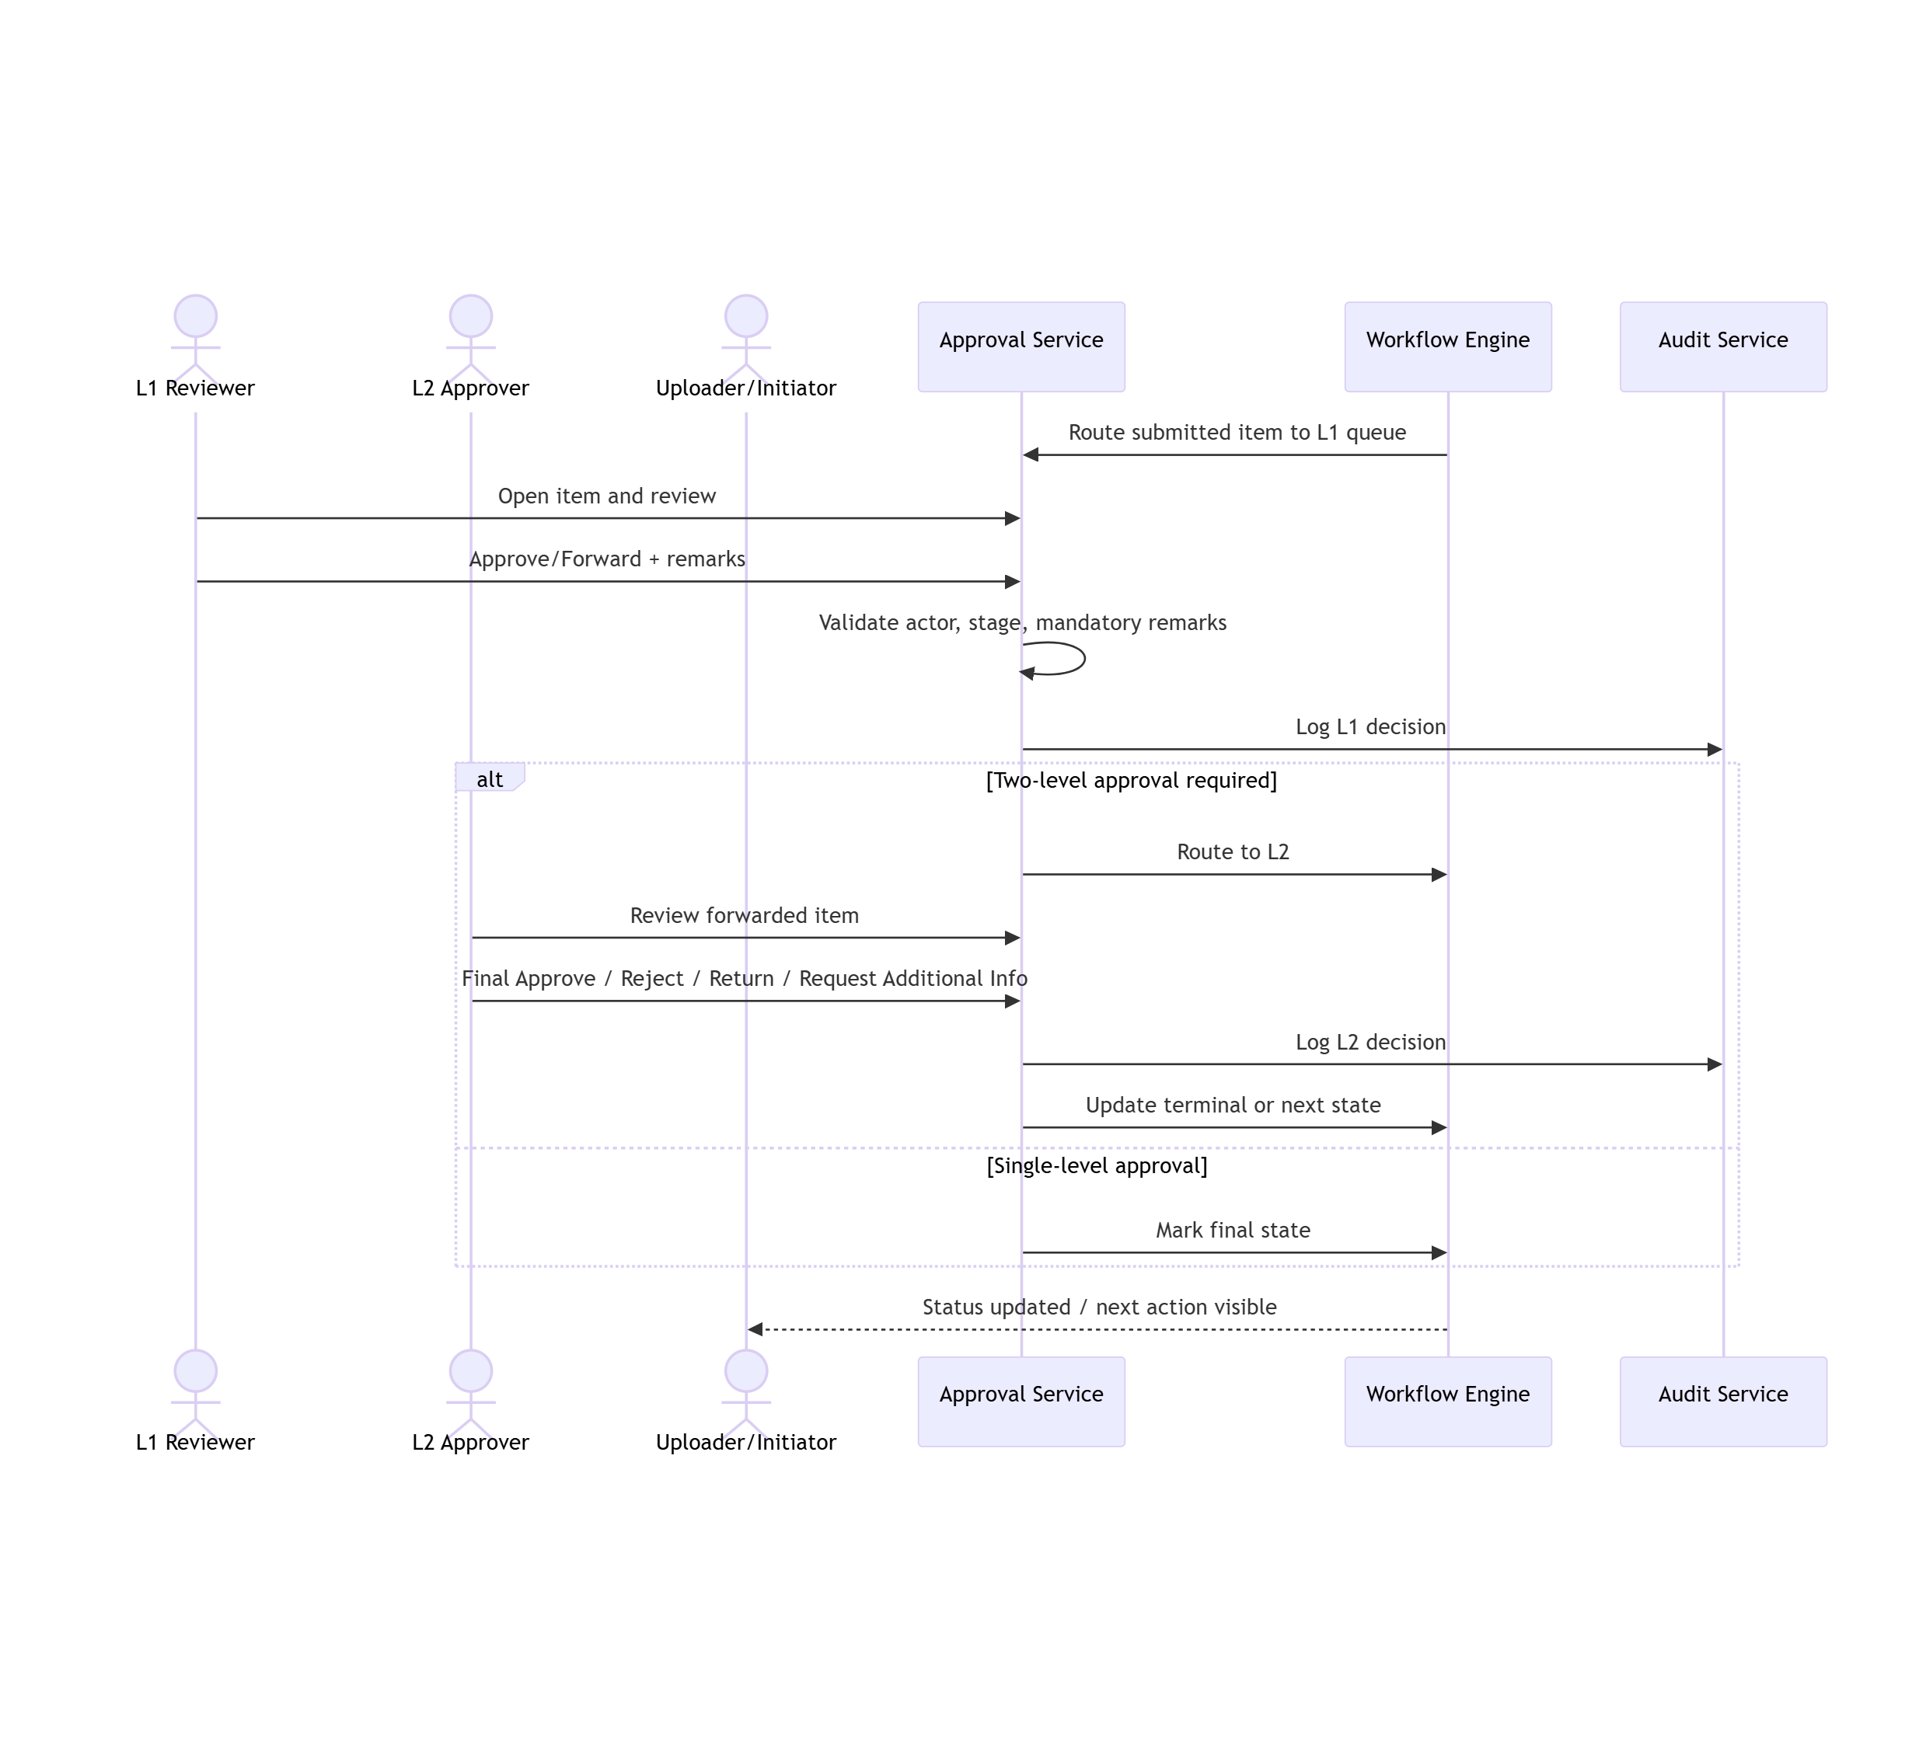

5. Proposed Detailed API Contracts
The source docs explicitly say the module should expose RESTful APIs, use Java-based microservices, and support REST/Webhook integrations.
The contracts below are therefore a proposed implementation design, not a verbatim interface catalogue from source docs.

5.1 Bulk package upload
Purpose: Accept only secure packages generated through the approved utility, validate them, generate acknowledgement/reference, and place them into workflow. This aligns to UC-DU-04.

POST /api/v1/data-uploads/bulk/packages
Auth: JWT/OAuth2 + RBAC
Content-Type: multipart/form-data
Request parts (proposed):
- packageFile (mandatory, file)
- remarks (optional, string, max 500)
Validation basis from SRS:
- user session and upload rights valid
- valid secure package type / uploadable structure
- configured file/package checks
- configured size limits
- acknowledgement/reference generated on success
Proposed response — 202 Accepted
1 {
2 "uploadId": "BULK-20260715-000145",
3 "status": "SUBMITTED",
4 "acknowledgementId": "ACK-20260715-893211",
5 "submittedAt": "2026-07-15T11:42:03+05:30",
6 "message": "Secure package uploaded successfully."
7 }
Proposed errors
- 400 invalid package
- 401 session expired
- 403 unauthorized
- 413 size rule violation
- 422 validation failed
- 500 upload/storage failure
Suggested error code mapping to SRS messages
- UC04-MSG-001 session expired
- UC04-MSG-002 unauthorized
- UC04-MSG-003 invalid package
- UC04-MSG-004 package validation failed
- UC04-MSG-005 upload failed

5.2 Bulk upload tracking

GET /api/v1/data-uploads/bulk/packages/{uploadId}
Purpose: Return current status, acknowledgement, last workflow state, validation outcome, and audit summary for the bulk upload. This is consistent with the SRS requirement to keep upload status, reference details, and errors visible to the user.
Proposed response
1 {
2 "uploadId": "BULK-20260715-000145",
3 "status": "UNDER_REVIEW",
4 "acknowledgementId": "ACK-20260715-893211",
5 "submittedAt": "2026-07-15T11:42:03+05:30",
6 "lastUpdatedAt": "2026-07-15T11:46:18+05:30",
7 "validationSummary": {
8 "result": "PASSED",
9 "warnings": []
10 },
11 "currentWorkflowStage": "PENDING_APPROVAL_L1"
12 }

5.3 One-by-one record create / draft save

POST /api/v1/data-uploads/records
Purpose: Create a one-by-one in-progress record or draft. This aligns to UC-DU-05, which supports screen-based entry, metadata/details capture, optional attachments, and draft save where enabled.
Proposed request
1 {
2 "mode": "DRAFT",
3 "informationCategory": "CRIU",
4 "financialYear": "2025-26",
5 "sourceContext": "SURVEY",
6 "subjectType": "POTENTIAL_TAX_EVASION",
7 "primaryIdentifier": {
8 "type": "PAN",
9 "value": "ABCDE1234F"
10 },
11 "details": {
12 "sourceName": "ABC Traders",
13 "description": "High-value unexplained cash movement observed.",
14 "transactionValue": 2450000,
15 "eventDate": "2026-07-01"
16 },
17 "remarks": "Initial field capture."
18 }
Proposed response — 201 Created
1 {
2 "recordId": "REC-20260715-001928",
3 "status": "DRAFT",
4 "message": "Information record saved as draft successfully."
5 }
SRS-aligned validations
- mandatory metadata fields
- format/value/dependency rules
- dynamic-field applicability
- document rules where applicable

5.4 Add / replace attachment

POST /api/v1/data-uploads/records/{recordId}/attachments
Purpose: Attach supporting documents to one-by-one records. This aligns to the SRS requirement for file attachment support, document linkage, and validation of attachment rules.
Request: multipart/form-data
- file (mandatory)
- documentType (mandatory)
- documentDescription (optional)
Proposed response
1 {
2 "attachmentId": "ATT-20260715-884102",
3 "recordId": "REC-20260715-001928",
4 "status": "ATTACHED"
5 }

5.5 Submit one-by-one record

POST /api/v1/data-uploads/records/{recordId}/submit
Purpose: Final submission after full validation. This aligns to UC-DU-05.
Proposed response
1 {
2 "recordId": "REC-20260715-001928",
3 "status": "SUBMITTED",
4 "trackingId": "TRK-20260715-122771",
5 "message": "Information submitted successfully."
6 }
Suggested error mapping
- UC05-MSG-001 session expired
- UC05-MSG-002 unauthorized
- UC05-MSG-003 mandatory field / validation failure
- UC05-MSG-004 invalid supporting document
- UC05-MSG-005 submission failed

5.6 Approval queue

GET /api/v1/data-uploads/approvals/pending
Purpose: Fetch reviewer/approver worklist. This aligns to UC-DU-06, where the reviewer opens the assigned item from the queue/worklist.
Proposed response
1 {
2 "items": [
3 {
4 "itemId": "APR-20260715-0012",
5 "sourceRecordId": "REC-20260715-001928",
6 "currentStage": "L1",
7 "status": "PENDING_APPROVAL_L1",
8 "submittedBy": "USER-23918",
9 "submittedAt": "2026-07-15T11:54:27+05:30"
10 }
11 ]
12 }

5.7 Approval action

POST /api/v1/data-uploads/approvals/{itemId}/actions
Purpose: Record decisions such as Approve/Forward, Final Approve, Reject, Return for Correction, or Request Additional Information. This is directly aligned to UC-DU-06.
Proposed request
1 {
2 "action": "FORWARD",
3 "remarks": "L1 review completed. Forwarding for L2 approval."
4 }
Allowed actions (proposed):
- FORWARD
- FINAL_APPROVE
- REJECT
- RETURN_FOR_CORRECTION
- REQUEST_ADDITIONAL_INFO
Proposed response
1 {
2 "itemId": "APR-20260715-0012",
3 "status": "PENDING_APPROVAL_L2",
4 "message": "Workflow status updated successfully."
5 }
SRS-aligned validations
- only actions valid for the current user and workflow stage
- mandatory remarks if action requires them
- one valid next workflow state only
- sequential two-level approval when configured

5.8 Additional information request

POST /api/v1/data-uploads/records/{recordId}/additional-info-requests
Purpose: Create clarification request against a submitted/uploaded item. This aligns to the explicitly defined additional-information use case in the SRS.
Proposed request
1 {
2 "requestText": "Please provide source evidence for the reported cash movement.",
3 "dueDate": "2026-07-22",
4 "severity": "NORMAL"
5 }
Proposed response
1 {
2 "requestId": "AIR-20260715-54011",
3 "status": "PENDING_RESPONSE"
4 }

5.9 Additional information response

POST /api/v1/data-uploads/additional-info-requests/{requestId}/responses
Purpose: Uploader responds to a clarification request and optionally attaches supporting files. This aligns to the SRS request/response requirement.

6. Suggested non-functional implementation controls
The source docs require RBAC, audit trails, versioning of original/corrected/updated info, duplicate rejection, workflow controls, and traceability.

6.1 Proposed controls
- Idempotency key for bulk submission to avoid accidental duplicate upload
- Duplicate hash of secure package and document set
- Immutable audit event for create/edit/save/submit/approve/reject/return
- Soft versioning for record revisions: versionNo, supersedesRecordId
- Attachment checksum and content-type validation
- Workflow concurrency check (version / optimistic locking)
- RBAC policy matrix by role: uploader / reviewer / approver / viewer
- PII tagging for sensitive/very sensitive uploads
- Async downstream event after approval for profile linkage and analytics use

7. Suggested database tables (proposed)
1 upload_batch(
2 upload_id PK,
3 acknowledgement_id,
4 status,
5 remarks,
6 package_hash,
7 submitted_by,
8 submitted_at,
9 current_workflow_stage
10 )
11
12 upload_record(
13 record_id PK,
14 mode,
15 category,
16 financial_year,
17 primary_identifier_type,
18 primary_identifier_value,
19 payload_json,
20 status,
21 version_no,
22 supersedes_record_id,
23 created_by,
24 created_at,
25 updated_at
26 )
27
28 attachment(
29 attachment_id PK,
30 record_id FK,
31 document_type,
32 file_name,
33 content_type,
34 file_size,
35 checksum,
36 blob_ref,
37 attached_by,
38 attached_at
39 )
40
41 approval_instance(
42 item_id PK,
43 source_type,
44 source_id,
45 stage_no,
46 status,
47 assigned_to,
48 created_at,
49 updated_at
50 )
51
52 approval_action(
53 action_id PK,
54 item_id FK,
55 action,
56 remarks,
57 acted_by,
58 acted_at
59 )
60
61 additional_info_request(
62 request_id PK,
63 record_id FK,
64 request_text,
65 due_date,
66 status,
67 requested_by,
68 requested_at
69 )
70
71 additional_info_response(
72 response_id PK,
73 request_id FK,
74 response_text,
75 responded_by,
76 responded_at
77 )
78
79 audit_event(
80 event_id PK,
81 entity_type,
82 entity_id,
83 action,
84 actor_id,
85 event_ts,
86 before_json,
87 after_json
88 )

8. Quick traceability snapshot
- Bulk utility packet preparation and XML generation → UC-DU-02
- Secure package generation → UC-DU-03
- Portal bulk upload, ack/reference, workflow intake → UC-DU-04
- One-by-one create/draft/submit/track → UC-DU-05
- Two-level approval / reject / return / additional info → UC-DU-06
- PAN/TAN/ITDREIN/profile linkage and downstream use → FRS/SRS module scope and inter-module behavior

9. Best next step
If this is the right module, I can immediately do one of these next in the same format:
- expand the API contracts into full request/response/error schema tables, or
- add database DDL drafts + state transition table + error catalogue, or
- remap this into the exact headings of your LLD template once you paste the template headings or give me the exact module name.

https://ltimindtree.sharepoint.com/sites/Insight/Shared%20Documents/Profile%20View/v1/LLD?web=1
https://ltimindtree.sharepoint.com/sites/Insight/_layouts/15/Doc.aspx?sourcedoc=%7BA5773A92-DCC5-493D-A502-08B68B49CB1A%7D\&file=Project%20Insight%202.0_FRS_DataUploads_v1.0_v1.0.docx\&action=default\&mobileredirect=true\&DefaultItemOpen=1
https://ltimindtree.sharepoint.com/sites/Insight/_layouts/15/Doc.aspx?sourcedoc=%7BF3AB4B2D-35BC-463A-A081-5776C9E1717F%7D\&file=Project%20Insight%202.0_SRS_DataUploads_v1.2.docx\&action=default\&mobileredirect=true\&DefaultItemOpen=1
https://ltimindtree.sharepoint.com/sites/Insight/_layouts/15/Doc.aspx?sourcedoc=%7B8CFE8139-2462-47D5-AC1C-C8FED63E667F%7D\&file=CBDT_Insight_2_0_HLD_V_1_1_v1.0.docx\&action=default\&mobileredirect=true\&DefaultItemOpen=1
https://ltimindtree.sharepoint.com/sites/Insight/_layouts/15/Doc.aspx?sourcedoc=%7BB03E321E-33BE-4A08-8791-E2276AC41830%7D\&file=CBDT_Insight_2.0_Data_HLD_V_1.1_v1.0.docx\&action=default\&mobileredirect=true\&DefaultItemOpen=1
https://ltimindtree.sharepoint.com/sites/Insight/_layouts/15/Doc.aspx?sourcedoc=%7BF0606FA4-3098-4A6A-85D0-5014CF24A6E0%7D\&file=CBDT_Insights_2_0_Solution_Architecture_V_1.1_v1.0.docx\&action=default\&mobileredirect=true\&DefaultItemOpen=1
https://ltimindtree.sharepoint.com/sites/Insight/_layouts/15/Doc.aspx?sourcedoc=%7BA5773A92-DCC5-493D-A502-08B68B49CB1A%7D\&file=Project%20Insight%202.0_FRS_DataUploads_v1.0_v1.0.docx\&action=default\&mobileredirect=true\&DefaultItemOpen=1
https://ltimindtree.sharepoint.com/sites/Insight/_layouts/15/Doc.aspx?sourcedoc=%7BF3AB4B2D-35BC-463A-A081-5776C9E1717F%7D\&file=Project%20Insight%202.0_SRS_DataUploads_v1.2.docx\&action=default\&mobileredirect=true\&DefaultItemOpen=1
https://ltimindtree.sharepoint.com/sites/Insight/_layouts/15/Doc.aspx?sourcedoc=%7B8CFE8139-2462-47D5-AC1C-C8FED63E667F%7D\&file=CBDT_Insight_2_0_HLD_V_1_1_v1.0.docx\&action=default\&mobileredirect=true\&DefaultItemOpen=1
https://ltimindtree.sharepoint.com/sites/Insight/_layouts/15/Doc.aspx?sourcedoc=%7BF0606FA4-3098-4A6A-85D0-5014CF24A6E0%7D\&file=CBDT_Insights_2_0_Solution_Architecture_V_1.1_v1.0.docx\&action=default\&mobileredirect=true\&DefaultItemOpen=1
https://ltimindtree.sharepoint.com/sites/Insight/_layouts/15/Doc.aspx?sourcedoc=%7BF3AB4B2D-35BC-463A-A081-5776C9E1717F%7D\&file=Project%20Insight%202.0_SRS_DataUploads_v1.2.docx\&action=default\&mobileredirect=true\&DefaultItemOpen=1
https://ltimindtree.sharepoint.com/sites/Insight/_layouts/15/Doc.aspx?sourcedoc=%7BF3AB4B2D-35BC-463A-A081-5776C9E1717F%7D\&file=Project%20Insight%202.0_SRS_DataUploads_v1.2.docx\&action=default\&mobileredirect=true\&DefaultItemOpen=1
https://ltimindtree.sharepoint.com/sites/Insight/_layouts/15/Doc.aspx?sourcedoc=%7B8CFE8139-2462-47D5-AC1C-C8FED63E667F%7D\&file=CBDT_Insight_2_0_HLD_V_1_1_v1.0.docx\&action=default\&mobileredirect=true\&DefaultItemOpen=1
https://ltimindtree.sharepoint.com/sites/Insight/_layouts/15/Doc.aspx?sourcedoc=%7BA5773A92-DCC5-493D-A502-08B68B49CB1A%7D\&file=Project%20Insight%202.0_FRS_DataUploads_v1.0_v1.0.docx\&action=default\&mobileredirect=true\&DefaultItemOpen=1
https://ltimindtree.sharepoint.com/sites/Insight/_layouts/15/Doc.aspx?sourcedoc=%7BF3AB4B2D-35BC-463A-A081-5776C9E1717F%7D\&file=Project%20Insight%202.0_SRS_DataUploads_v1.2.docx\&action=default\&mobileredirect=true\&DefaultItemOpen=1
https://ltimindtree.sharepoint.com/sites/Insight/_layouts/15/Doc.aspx?sourcedoc=%7BF3AB4B2D-35BC-463A-A081-5776C9E1717F%7D\&file=Project%20Insight%202.0_SRS_DataUploads_v1.2.docx\&action=default\&mobileredirect=true\&DefaultItemOpen=1
https://ltimindtree.sharepoint.com/sites/Insight/_layouts/15/Doc.aspx?sourcedoc=%7B8CFE8139-2462-47D5-AC1C-C8FED63E667F%7D\&file=CBDT_Insight_2_0_HLD_V_1_1_v1.0.docx\&action=default\&mobileredirect=true\&DefaultItemOpen=1
https://ltimindtree.sharepoint.com/sites/Insight/_layouts/15/Doc.aspx?sourcedoc=%7BF0606FA4-3098-4A6A-85D0-5014CF24A6E0%7D\&file=CBDT_Insights_2_0_Solution_Architecture_V_1.1_v1.0.docx\&action=default\&mobileredirect=true\&DefaultItemOpen=1
https://ltimindtree.sharepoint.com/sites/Insight/_layouts/15/Doc.aspx?sourcedoc=%7BA5773A92-DCC5-493D-A502-08B68B49CB1A%7D\&file=Project%20Insight%202.0_FRS_DataUploads_v1.0_v1.0.docx\&action=default\&mobileredirect=true\&DefaultItemOpen=1
https://ltimindtree.sharepoint.com/sites/Insight/_layouts/15/Doc.aspx?sourcedoc=%7BF3AB4B2D-35BC-463A-A081-5776C9E1717F%7D\&file=Project%20Insight%202.0_SRS_DataUploads_v1.2.docx\&action=default\&mobileredirect=true\&DefaultItemOpen=1
https://ltimindtree.sharepoint.com/sites/Insight/_layouts/15/Doc.aspx?sourcedoc=%7B8CFE8139-2462-47D5-AC1C-C8FED63E667F%7D\&file=CBDT_Insight_2_0_HLD_V_1_1_v1.0.docx\&action=default\&mobileredirect=true\&DefaultItemOpen=1
https://ltimindtree.sharepoint.com/sites/Insight/_layouts/15/Doc.aspx?sourcedoc=%7BF0606FA4-3098-4A6A-85D0-5014CF24A6E0%7D\&file=CBDT_Insights_2_0_Solution_Architecture_V_1.1_v1.0.docx\&action=default\&mobileredirect=true\&DefaultItemOpen=1
https://ltimindtree.sharepoint.com/sites/Insight/_layouts/15/Doc.aspx?sourcedoc=%7BA5773A92-DCC5-493D-A502-08B68B49CB1A%7D\&file=Project%20Insight%202.0_FRS_DataUploads_v1.0_v1.0.docx\&action=default\&mobileredirect=true\&DefaultItemOpen=1
https://ltimindtree.sharepoint.com/sites/Insight/_layouts/15/Doc.aspx?sourcedoc=%7BF3AB4B2D-35BC-463A-A081-5776C9E1717F%7D\&file=Project%20Insight%202.0_SRS_DataUploads_v1.2.docx\&action=default\&mobileredirect=true\&DefaultItemOpen=1
https://ltimindtree.sharepoint.com/sites/Insight/_layouts/15/Doc.aspx?sourcedoc=%7BF3AB4B2D-35BC-463A-A081-5776C9E1717F%7D\&file=Project%20Insight%202.0_SRS_DataUploads_v1.2.docx\&action=default\&mobileredirect=true\&DefaultItemOpen=1
https://ltimindtree.sharepoint.com/sites/Insight/_layouts/15/Doc.aspx?sourcedoc=%7BF3AB4B2D-35BC-463A-A081-5776C9E1717F%7D\&file=Project%20Insight%202.0_SRS_DataUploads_v1.2.docx\&action=default\&mobileredirect=true\&DefaultItemOpen=1
https://ltimindtree.sharepoint.com/sites/Insight/_layouts/15/Doc.aspx?sourcedoc=%7BF3AB4B2D-35BC-463A-A081-5776C9E1717F%7D\&file=Project%20Insight%202.0_SRS_DataUploads_v1.2.docx\&action=default\&mobileredirect=true\&DefaultItemOpen=1
https://ltimindtree.sharepoint.com/sites/Insight/_layouts/15/Doc.aspx?sourcedoc=%7BF3AB4B2D-35BC-463A-A081-5776C9E1717F%7D\&file=Project%20Insight%202.0_SRS_DataUploads_v1.2.docx\&action=default\&mobileredirect=true\&DefaultItemOpen=1
https://ltimindtree.sharepoint.com/sites/Insight/_layouts/15/Doc.aspx?sourcedoc=%7BF3AB4B2D-35BC-463A-A081-5776C9E1717F%7D\&file=Project%20Insight%202.0_SRS_DataUploads_v1.2.docx\&action=default\&mobileredirect=true\&DefaultItemOpen=1
https://ltimindtree.sharepoint.com/sites/Insight/_layouts/15/Doc.aspx?sourcedoc=%7BF3AB4B2D-35BC-463A-A081-5776C9E1717F%7D\&file=Project%20Insight%202.0_SRS_DataUploads_v1.2.docx\&action=default\&mobileredirect=true\&DefaultItemOpen=1
https://ltimindtree.sharepoint.com/sites/Insight/_layouts/15/Doc.aspx?sourcedoc=%7BF3AB4B2D-35BC-463A-A081-5776C9E1717F%7D\&file=Project%20Insight%202.0_SRS_DataUploads_v1.2.docx\&action=default\&mobileredirect=true\&DefaultItemOpen=1
https://ltimindtree.sharepoint.com/sites/Insight/_layouts/15/Doc.aspx?sourcedoc=%7BF3AB4B2D-35BC-463A-A081-5776C9E1717F%7D\&file=Project%20Insight%202.0_SRS_DataUploads_v1.2.docx\&action=default\&mobileredirect=true\&DefaultItemOpen=1
https://ltimindtree.sharepoint.com/sites/Insight/_layouts/15/Doc.aspx?sourcedoc=%7BF3AB4B2D-35BC-463A-A081-5776C9E1717F%7D\&file=Project%20Insight%202.0_SRS_DataUploads_v1.2.docx\&action=default\&mobileredirect=true\&DefaultItemOpen=1
https://ltimindtree.sharepoint.com/sites/Insight/_layouts/15/Doc.aspx?sourcedoc=%7BF3AB4B2D-35BC-463A-A081-5776C9E1717F%7D\&file=Project%20Insight%202.0_SRS_DataUploads_v1.2.docx\&action=default\&mobileredirect=true\&DefaultItemOpen=1
https://ltimindtree.sharepoint.com/sites/Insight/_layouts/15/Doc.aspx?sourcedoc=%7BF3AB4B2D-35BC-463A-A081-5776C9E1717F%7D\&file=Project%20Insight%202.0_SRS_DataUploads_v1.2.docx\&action=default\&mobileredirect=true\&DefaultItemOpen=1
https://ltimindtree.sharepoint.com/sites/Insight/_layouts/15/Doc.aspx?sourcedoc=%7BF3AB4B2D-35BC-463A-A081-5776C9E1717F%7D\&file=Project%20Insight%202.0_SRS_DataUploads_v1.2.docx\&action=default\&mobileredirect=true\&DefaultItemOpen=1
https://ltimindtree.sharepoint.com/sites/Insight/_layouts/15/Doc.aspx?sourcedoc=%7BA5773A92-DCC5-493D-A502-08B68B49CB1A%7D\&file=Project%20Insight%202.0_FRS_DataUploads_v1.0_v1.0.docx\&action=default\&mobileredirect=true\&DefaultItemOpen=1
https://ltimindtree.sharepoint.com/sites/Insight/_layouts/15/Doc.aspx?sourcedoc=%7BF3AB4B2D-35BC-463A-A081-5776C9E1717F%7D\&file=Project%20Insight%202.0_SRS_DataUploads_v1.2.docx\&action=default\&mobileredirect=true\&DefaultItemOpen=1
https://ltimindtree.sharepoint.com/sites/Insight/_layouts/15/Doc.aspx?sourcedoc=%7BF3AB4B2D-35BC-463A-A081-5776C9E1717F%7D\&file=Project%20Insight%202.0_SRS_DataUploads_v1.2.docx\&action=default\&mobileredirect=true\&DefaultItemOpen=1
https://ltimindtree.sharepoint.com/sites/Insight/_layouts/15/Doc.aspx?sourcedoc=%7BF3AB4B2D-35BC-463A-A081-5776C9E1717F%7D\&file=Project%20Insight%202.0_SRS_DataUploads_v1.2.docx\&action=default\&mobileredirect=true\&DefaultItemOpen=1
https://ltimindtree.sharepoint.com/sites/Insight/_layouts/15/Doc.aspx?sourcedoc=%7BF3AB4B2D-35BC-463A-A081-5776C9E1717F%7D\&file=Project%20Insight%202.0_SRS_DataUploads_v1.2.docx\&action=default\&mobileredirect=true\&DefaultItemOpen=1
https://ltimindtree.sharepoint.com/sites/Insight/_layouts/15/Doc.aspx?sourcedoc=%7BF3AB4B2D-35BC-463A-A081-5776C9E1717F%7D\&file=Project%20Insight%202.0_SRS_DataUploads_v1.2.docx\&action=default\&mobileredirect=true\&DefaultItemOpen=1
https://ltimindtree.sharepoint.com/sites/Insight/_layouts/15/Doc.aspx?sourcedoc=%7BF3AB4B2D-35BC-463A-A081-5776C9E1717F%7D\&file=Project%20Insight%202.0_SRS_DataUploads_v1.2.docx\&action=default\&mobileredirect=true\&DefaultItemOpen=1
https://ltimindtree.sharepoint.com/sites/Insight/_layouts/15/Doc.aspx?sourcedoc=%7BF3AB4B2D-35BC-463A-A081-5776C9E1717F%7D\&file=Project%20Insight%202.0_SRS_DataUploads_v1.2.docx\&action=default\&mobileredirect=true\&DefaultItemOpen=1
https://ltimindtree.sharepoint.com/sites/Insight/_layouts/15/Doc.aspx?sourcedoc=%7BA5773A92-DCC5-493D-A502-08B68B49CB1A%7D\&file=Project%20Insight%202.0_FRS_DataUploads_v1.0_v1.0.docx\&action=default\&mobileredirect=true\&DefaultItemOpen=1
https://ltimindtree.sharepoint.com/sites/Insight/_layouts/15/Doc.aspx?sourcedoc=%7BF3AB4B2D-35BC-463A-A081-5776C9E1717F%7D\&file=Project%20Insight%202.0_SRS_DataUploads_v1.2.docx\&action=default\&mobileredirect=true\&DefaultItemOpen=1
https://ltimindtree.sharepoint.com/sites/Insight/_layouts/15/Doc.aspx?sourcedoc=%7BA5773A92-DCC5-493D-A502-08B68B49CB1A%7D\&file=Project%20Insight%202.0_FRS_DataUploads_v1.0_v1.0.docx\&action=default\&mobileredirect=true\&DefaultItemOpen=1
https://ltimindtree.sharepoint.com/sites/Insight/_layouts/15/Doc.aspx?sourcedoc=%7BF3AB4B2D-35BC-463A-A081-5776C9E1717F%7D\&file=Project%20Insight%202.0_SRS_DataUploads_v1.2.docx\&action=default\&mobileredirect=true\&DefaultItemOpen=1
https://ltimindtree.sharepoint.com/sites/Insight/_layouts/15/Doc.aspx?sourcedoc=%7B8CFE8139-2462-47D5-AC1C-C8FED63E667F%7D\&file=CBDT_Insight_2_0_HLD_V_1_1_v1.0.docx\&action=default\&mobileredirect=true\&DefaultItemOpen=1
https://ltimindtree.sharepoint.com/sites/Insight/_layouts/15/Doc.aspx?sourcedoc=%7BF0606FA4-3098-4A6A-85D0-5014CF24A6E0%7D\&file=CBDT_Insights_2_0_Solution_Architecture_V_1.1_v1.0.docx\&action=default\&mobileredirect=true\&DefaultItemOpen=1
https://ltimindtree.sharepoint.com/sites/Insight/_layouts/15/Doc.aspx?sourcedoc=%7BF3AB4B2D-35BC-463A-A081-5776C9E1717F%7D\&file=Project%20Insight%202.0_SRS_DataUploads_v1.2.docx\&action=default\&mobileredirect=true\&DefaultItemOpen=1
https://ltimindtree.sharepoint.com/sites/Insight/_layouts/15/Doc.aspx?sourcedoc=%7BF3AB4B2D-35BC-463A-A081-5776C9E1717F%7D\&file=Project%20Insight%202.0_SRS_DataUploads_v1.2.docx\&action=default\&mobileredirect=true\&DefaultItemOpen=1
https://ltimindtree.sharepoint.com/sites/Insight/_layouts/15/Doc.aspx?sourcedoc=%7BF3AB4B2D-35BC-463A-A081-5776C9E1717F%7D\&file=Project%20Insight%202.0_SRS_DataUploads_v1.2.docx\&action=default\&mobileredirect=true\&DefaultItemOpen=1
https://ltimindtree.sharepoint.com/sites/Insight/_layouts/15/Doc.aspx?sourcedoc=%7BF3AB4B2D-35BC-463A-A081-5776C9E1717F%7D\&file=Project%20Insight%202.0_SRS_DataUploads_v1.2.docx\&action=default\&mobileredirect=true\&DefaultItemOpen=1
https://ltimindtree.sharepoint.com/sites/Insight/_layouts/15/Doc.aspx?sourcedoc=%7BF3AB4B2D-35BC-463A-A081-5776C9E1717F%7D\&file=Project%20Insight%202.0_SRS_DataUploads_v1.2.docx\&action=default\&mobileredirect=true\&DefaultItemOpen=1
https://ltimindtree.sharepoint.com/sites/Insight/_layouts/15/Doc.aspx?sourcedoc=%7BA5773A92-DCC5-493D-A502-08B68B49CB1A%7D\&file=Project%20Insight%202.0_FRS_DataUploads_v1.0_v1.0.docx\&action=default\&mobileredirect=true\&DefaultItemOpen=1
https://ltimindtree.sharepoint.com/sites/Insight/_layouts/15/Doc.aspx?sourcedoc=%7BF3AB4B2D-35BC-463A-A081-5776C9E1717F%7D\&file=Project%20Insight%202.0_SRS_DataUploads_v1.2.docx\&action=default\&mobileredirect=true\&DefaultItemOpen=1

